**CCL Case Study No. 2**

**Topic:** Application of IoT/Ubiquitous based on cloud.

**Subtopic:** Stack4Things: an OpenStack-based framework for IoT.

**Problem Statement:**

The growth of IoT devices has created a need for a scalable and flexible infrastructure to manage and deploy these devices. Traditional infrastructure solutions may not be suitable for managing large-scale IoT deployments. Furthermore, managing IoT devices can be challenging due to the heterogeneity of devices, operating systems, and protocols used. To address these challenges, the research paper proposes a framework for managing IoT devices using OpenStack.

**Introduction**

The Internet of Things (IoT) is a rapidly growing area of technology that is revolutionizing the way we interact with our environment. As the number of IoT devices continues to grow, there is a need for a scalable and flexible infrastructure to support these devices. This case study focuses on the research paper titled "Stack4Things: an OpenStack-based framework for IoT," which proposes a framework for managing IoT devices using OpenStack, an open-source cloud computing platform.

Stack4Things is an OpenStack-based framework implementing the Sensing-and-Actuation-as-a-Service paradigm. The following diagram depicts the architecture of SAaaS architecture of the Stack4Things:

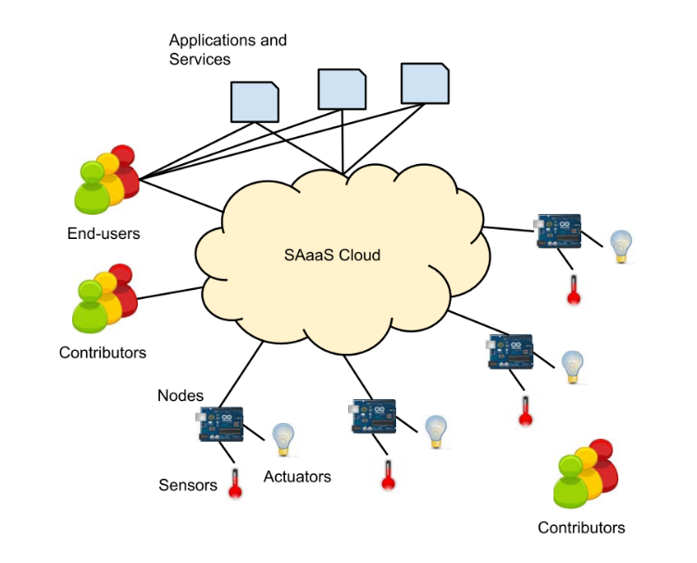

A vision for the integration of sensing and actuation devices in the Cloud infrastructure as part of the Software as a Service (SAaaS) model. The goal is to handle these devices in the same way as computing and storage resources, by virtualizing and multiplexing them over hardware resources, even if they are geographically dispersed. To achieve this, a set of APIs is required to remotely control these devices, thus enabling remote manipulation of the physical world through the user interfaces of the Cloud framework. This approach would enable the provision of services related to the sensing and actuation infrastructure on-demand, in an elastic and Quality of Service (QoS) guaranteed way. The overall goal is to make it easier to implement and provide application-level services to end-users on top of this infrastructure.

**Methodology:**

The proposed framework, called Stack4Things, is based on OpenStack, an open-source cloud computing platform that provides a range of services, including compute, storage, and networking. Stack4Things extends OpenStack to provide a cloud-based infrastructure for IoT devices, making it easier to manage and deploy IoT applications. The framework consists of several components, including OpenStack, IoT agents, the Stack4Things API, and application templates.

The IoT agents are installed on IoT devices and communicate with the OpenStack cloud infrastructure to provide real-time data and status updates. The Stack4Things API provides a unified interface for developers to interact with the Stack4Things framework and deploy IoT applications. The application templates provide a starting point for developers to create and deploy IoT applications using the Stack4Things framework.

The methodology is composed of several steps, including:

**Requirement analysis:** The authors start by analyzing the requirements of IoT systems and identifying the challenges that need to be addressed when building an OpenStack-based framework for IoT.

**Design:** Based on the requirements analysis, the authors design a framework architecture that includes the necessary components to manage IoT devices and data.

**Implementation:** The authors implement the designed framework using OpenStack services and components, such as Nova, Glance, Keystone, and Horizon.

**Testing:** The authors conduct several tests to evaluate the performance and scalability of the framework. The tests include both synthetic workloads and real-world IoT use cases.

**Evaluation:** Based on the test results, the authors evaluate the effectiveness of the framework in addressing the challenges identified in the requirement analysis.

**Deployment:** Finally, the authors provide guidelines for deploying the framework in production environments.

Overall, the methodology is iterative, meaning that the authors refine the design, implementation, and testing based on the results of each step. The goal is to build a scalable and flexible framework that can handle the dynamic and heterogeneous nature of IoT systems while ensuring high performance and reliability.

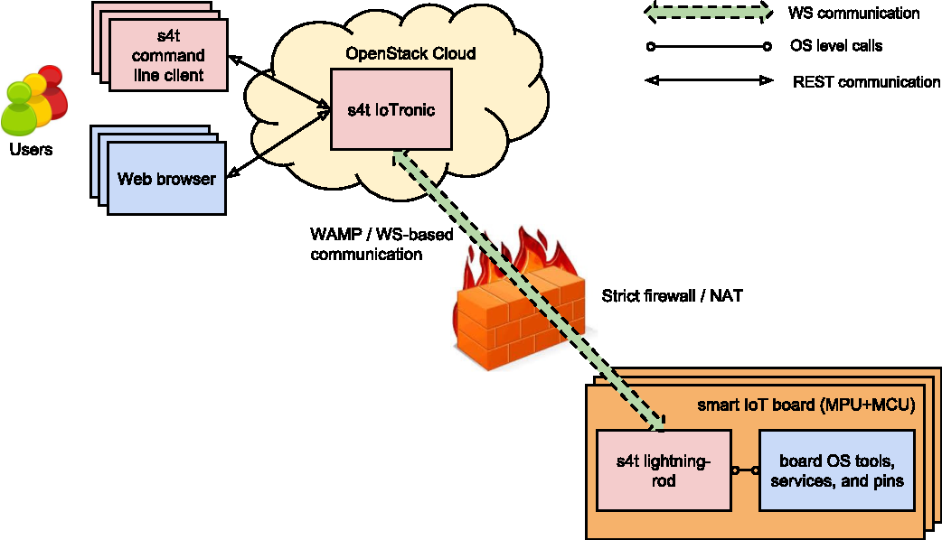

**Stack4Things overall architecture for Arduino YUN-like boards.**

**Cloud Side Control and Actuation**

Cloud-side control and actuation refer to the ability to remotely control and manage IoT devices from a cloud-based infrastructure. This means that the cloud platform acts as a central point of control for the IoT devices, allowing users to monitor and manage their operations, as well as interact with them in real-time.

To enable cloud-side control and actuation, the Stack4Things framework leverages the capabilities of OpenStack services, such as Nova, Glance, Keystone, and Horizon, to manage the resources needed to support IoT devices. Specifically, Nova is used to manage virtual machines that run on physical servers, Glance is used for storing and retrieving virtual machine images, and Keystone is used for authentication and authorization of users.

In addition, the framework also includes a set of components for managing IoT devices, such as the Stack4Things Agent and the Stack4Things Manager. The Stack4Things Agent is a lightweight software component that runs on the IoT device and enables communication with the cloud platform. The Stack4Things Manager, on the other hand, is responsible for managing the virtual machines that host the IoT device software, as well as for handling the communication between the cloud platform and the IoT devices.

Overall, the cloud-side control and actuation provided by the Stack4Things framework enables users to manage and monitor their IoT devices from a central location, providing greater flexibility and scalability for IoT deployments.

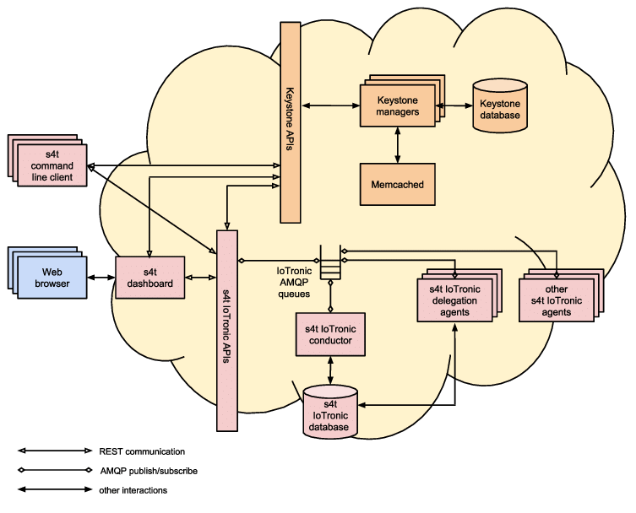

**Stack4Things Cloud Side Architecture**

**Use case: SSH connection toward a node**

This use case involves using Stack4Things to access a device connected to the IoT infrastructure and remotely execute commands on it.

To achieve this, Stack4Things provides an API for accessing the virtual machines created on the OpenStack-based Cloud infrastructure. The virtual machines can be used as gateways for accessing the devices connected to the IoT infrastructure.

In this use case, a user can use the API to request a virtual machine that is connected to the same network as the device they want to access. Once the virtual machine is created, the user can connect to it using an SSH client and remotely execute commands on the device.

This use case is particularly useful for scenarios where it is not feasible or desirable to have direct access to the devices connected to the IoT infrastructure. By using a virtual machine as a gateway, the user can still remotely access and control the device without compromising its security or exposing it to the public internet.

**Results**

The Stack4Things framework has been tested in several real-world scenarios, including smart home automation, precision agriculture, and smart city infrastructure. The results show that the framework provides a scalable and flexible platform for deploying and managing IoT applications. The framework is highly customizable and can be tailored to meet the specific needs of different IoT applications. By using the Stack4Things framework, developers can create and deploy IoT applications quickly and efficiently, reducing the time and cost of development.

**Conclusions**

The Stack4Things framework provides a powerful platform for deploying and managing IoT applications. It utilizes the capabilities of OpenStack to provide a scalable and flexible cloud-based infrastructure for IoT devices. The framework is highly customizable and can be tailored to meet the specific needs of different IoT applications. The framework has been tested in several real-world scenarios and has shown promising results. By using the Stack4Things framework, developers can create and deploy IoT applications quickly and efficiently, reducing the time and cost of development. Overall, the Stack4Things framework is a valuable addition to the growing IoT ecosystem, providing a scalable and flexible infrastructure for managing and deploying IoT applications.